**Smith Brothers**

Website: <https://smithbrothersfurniture.com/>

#01

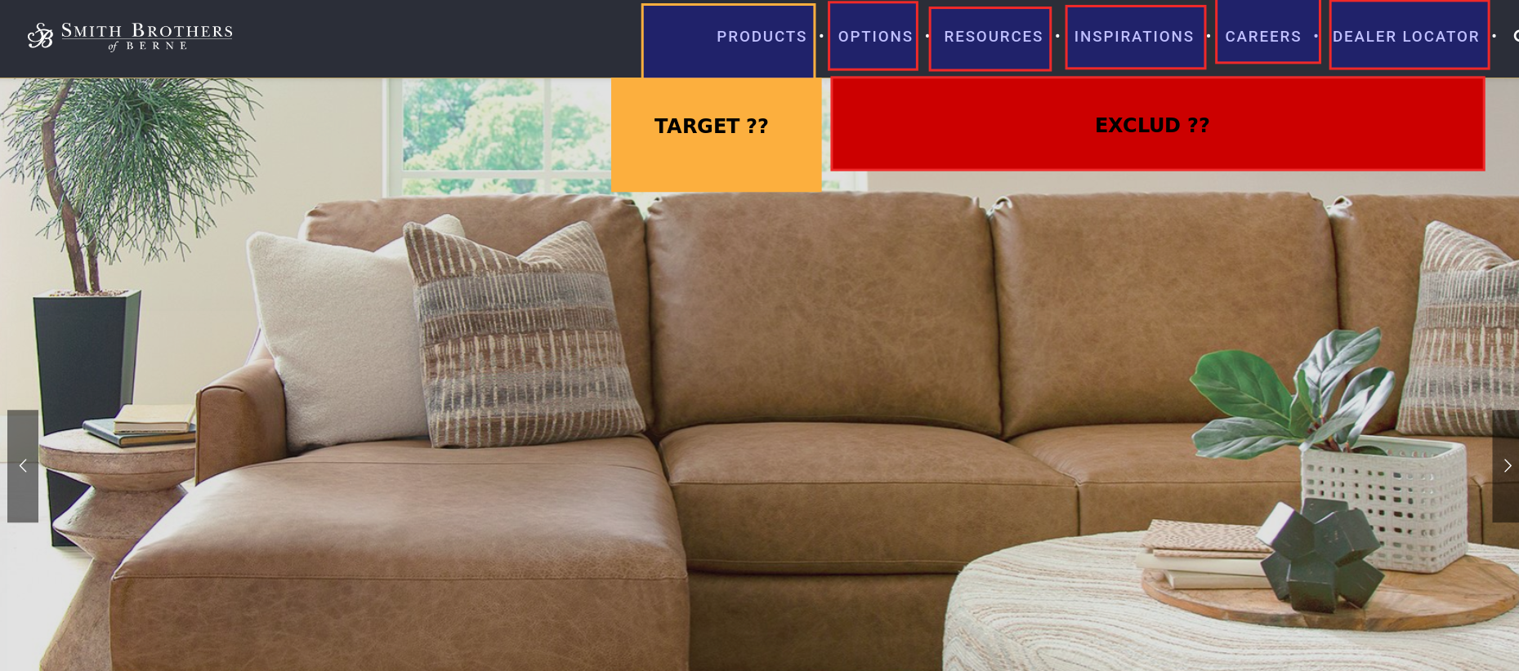

Targeting all these tabs

Response: Yes ,target Products highlighted in yellow per the top nav and exclude other values in red.

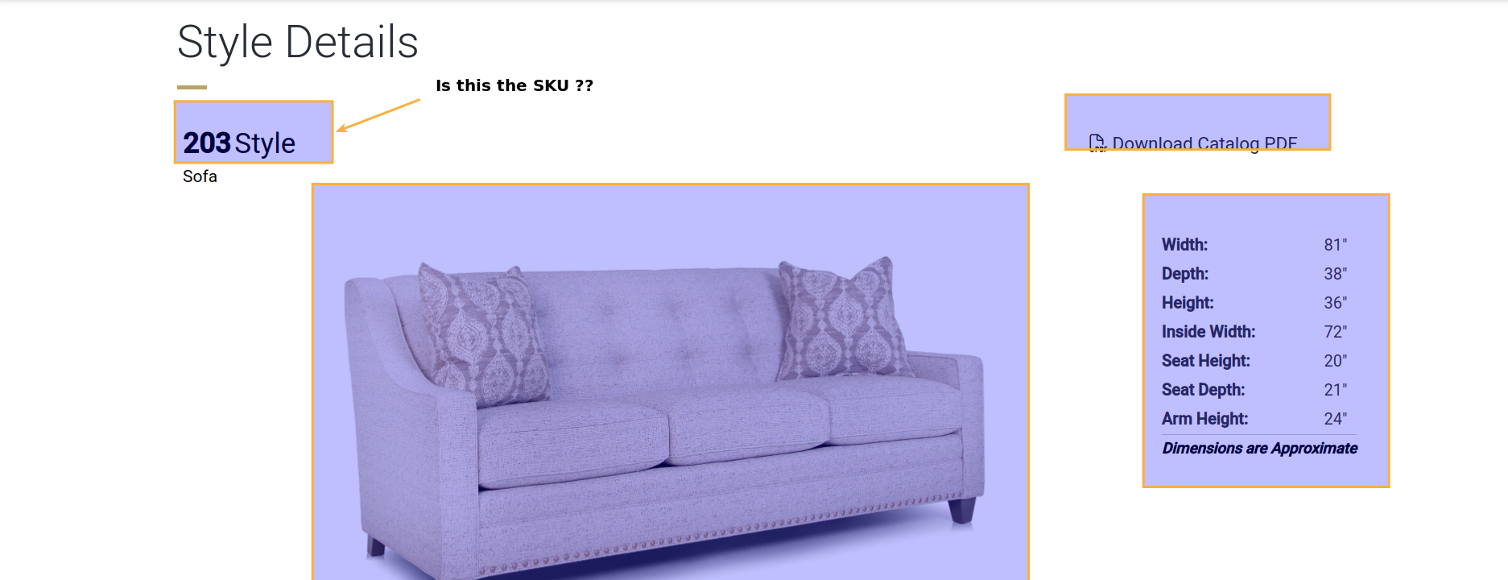

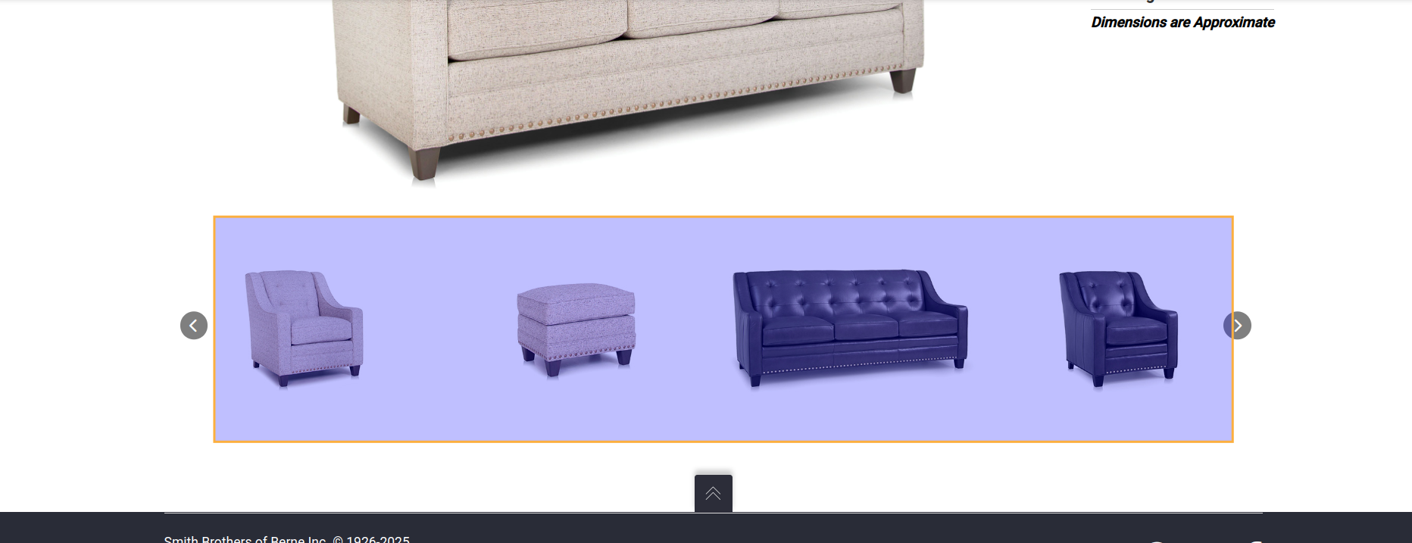

Please confirm if the marked data is correct (in yellow), that we need.

Response: In referencing the skus, it appears overall items do not have a defined sku available on the main product page, but rather the actual sku name is found only in the Download Catalog PDF. I do not believe this one will be feasible to scrape, we will most likely have to continue to update this one as manual, also in referencing the various images via the slider it may be hard to match these up to the appropriate sku but let me know if you have any suggestions. If not, we will continue this one as manual.